LOGARITHMS AND FUNCTIONS

<___question>

Type=1

<_block>

Which of these graphs does **not** represent a function ?

<_block>

[A] 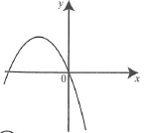

<_block>

[B] 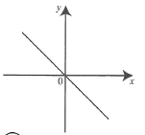

<_block>

[C] 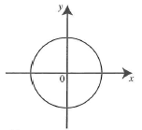

<_block>

[D] 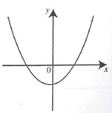

<_block>

[C]

<___question>

Type=1

<_block>

If log, *4 = 0.712*, which of these is equal to log*, $\sqrt{a }$* ?

<_block>

[A] $0.178$

<_block>

[B] $0.844$

<_block>

[C] $\frac{a}{2}$

<_block>

[D] $\frac{1}{2}$

<_block>

[D]

<___question>

Type=1

<_block>

Which of these is equal to (2**⁴**)² ?

<_block>

[A] $2⁶$

<_block>

[B] $2⁸$

<_block>

[C] $4²$

<_block>

[D] $8²$

<_block>

[B]

<___question>

Type=1

<_block>

If *y = 2x² - 8*, what is the value of positive *x* when *y = 0* ?

<_block>

[A] 2

<_block>

[B] $√6$

<_block>

[C] $4$

<_block>

[D] $8$

<_block>

[A]

<___question>

Type=1

<_block>

What is the solution of the equation 1.005ᶰ = 1.897, correct to three significant figures?

<_block>

[A] $n=125$

<_block>

[B] $n= 126$

<_block>

[C] $n=127$

<_block>

[D] $n=128$

<_block>

[D]

<___question>

Which of these is the point of intersection of *y = x* and the inverse function of *y = 2x – 1* ?

<_block>

[A] $(1, 1)$

<_block>

[B] $(2, 2)$

<_block>

[C] $(-1, -1)$

<_block>

[D] $(-2, -2)$

<_block>

[A]

<___question>

Type=1

<_block>

Between which two numbers is the value of *3⁵ ?*

<_block>

[A] $10 and 20$

<_block>

[B] $30 and 40$

<_block>

[C] $200 and 300$

<_block>

[D] $1000 and 1100$

<_block>

[C]

<___question>

Type=1

<_block>

The graph of y = 2 ͯis shown on the number plane. What is the value of *x = 3 ?*

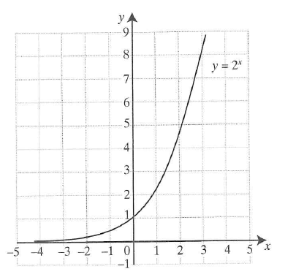

<_block>

[A] $1$

<_block>

[B] $6$

<_block>

[C] $8$

<_block>

[D] $12$

<_block>

[C]

<___question>

Type=1

<_block>

Which of these curves is cut at most once when a vertical line is drawn through it *?*

<_block>

[A] 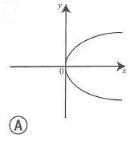

<_block>

[B] 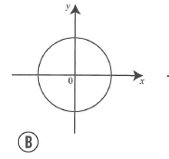

<_block>

[C]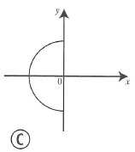

<_block>

[D]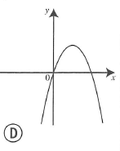

<_block>

[D]

<___question>

Type=1

<_block>

If $\sqrt{2x-1}= \sqrt{5},$ which of these is the value of *x ?*

<_block>

[A] $x=2$

<_block>

[B] $x=3$

<_block>

[C] $x=4$

<_block>

[D] $x=11$

<_block>

[B]